Title: How to Dress for Your Body Type
Keywords: dress body type, body shape fashion, hourglass, pear shape, apple shape, rectangle shape, inverted triangle, petite style, plus-size fashion
Short Description: Find easy and practical tips to dress in a way that suits your body shape and makes you feel confident and comfortable daily

How to Dress for Your Body Type
"Dress to flatter your figure by choosing styles that highlight your best features. Find the right fit for every body shape with these simple tips."
Everyone's body is unique, and that's a good thing.
Knowing your body type isn't about changing yourself; it's about choosing clothes that fit well and make you feel comfortable and confident.
Research shows that what you wear can affect how you feel and think, and how others see you. Clothes that suit your shape can help boost your confidence and make a strong impression.
Once you understand your body type, picking the right outfits becomes easier and less stressful.
Here's a simple guide to help you dress for your body shape.
How to Know Your Body Type
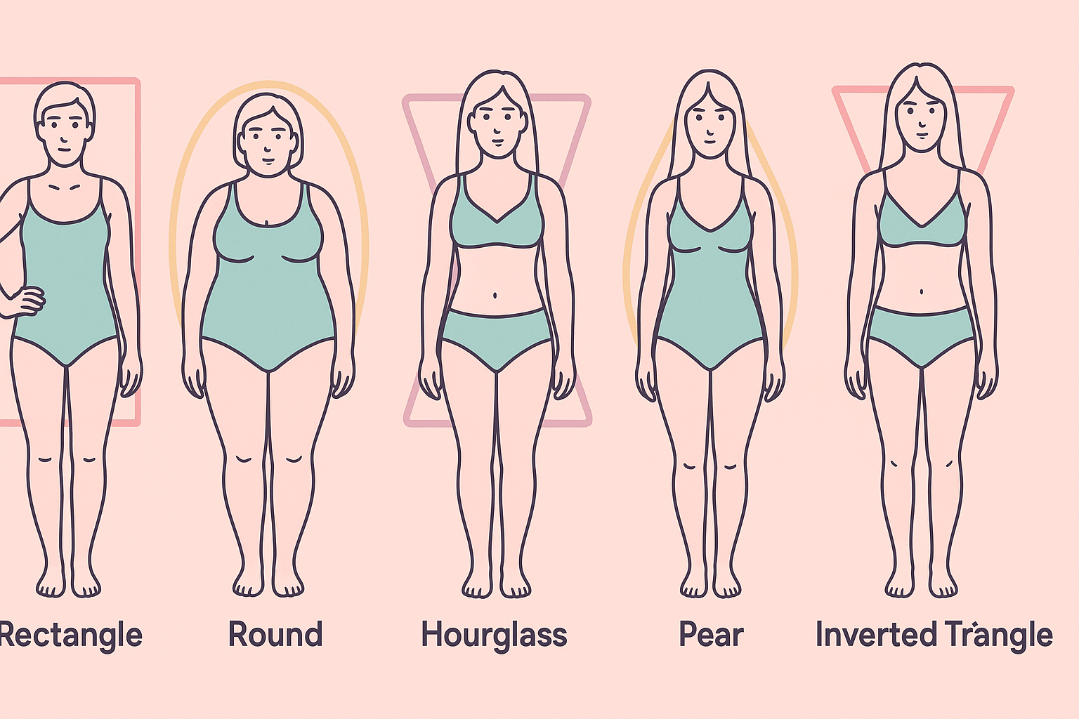
Body types are usually grouped based on the size of your bust, waist, and hips. The most common shapes include:
- Hourglass: Your bust and hips are about the same size, and your waist is clearly smaller.
- Pear (Triangle): Your hips are wider than your bust and shoulders.
- Apple (Inverted Triangle): Your shoulders and bust are broader than your hips.
- Rectangle: Your bust, waist, and hips are close in size, with little waist definition.
You can use a body shape calculator to find out your body type. This tool gives you a starting point by using your bust, waist, and hip measurements.
Step 1: Take Your Measurements
You'll need a measuring tape and something to write with. Measure these areas:
- Shoulders: Around the widest part.
- Bust: Around the fullest part of your chest.
- Waist: Around the smallest part, just above your belly button.
- Hips: Around the widest part of your hips and buttocks.
Step 2: Do the Math
Once you have your numbers, you can figure out your body type using these simple formulas:
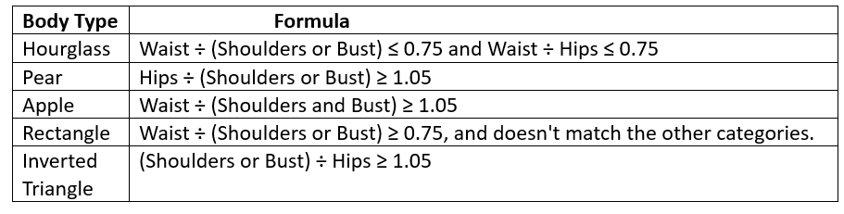
How to Dress for Your Body Shape
Here are easy tips to help you dress in a way that makes your body look balanced and highlights your best features.
1). Pear Shape (Triangle)
Your shape: Smaller shoulders and chest, wider hips and thighs.
What to wear:
- Tops: Go for tops that draw attention upward, like puff sleeves, off-shoulder styles, or anything with bright colors and fun prints.
- Waist: Use belts or fitted tops to show off your waist.
- Bottoms: Choose plain or dark-colored trousers and skirts that don't cling too tightly. A-line skirts and wide-leg trousers are great.
- Dresses: Pick styles that fit your top and flare at the bottom, like wrap or fit-and-flare dresses.
* Style tip: Wear short jackets or structured blazers to balance your shape.

2). Apple Shape (Round or Oval)
Your shape: Fuller at the tummy and chest, slimmer hips and legs.
What to wear:
- Tops: Choose tops with open necklines, such as V-necks or scoop necks. Loose tops that flow over the belly area work well.
- Jackets: Go for jackets that fall past your waist, like trench coats or longer blazers.
- Bottoms: Show off your legs with straight or slightly flared trousers. Avoid very tight jeans unless you wear a long top.
- Dresses: Empire waist or wrap dresses that flow under the bust are a good choice.
*Style tip: Wear clothes in one color to make your body look longer and leaner.
3). Rectangle Shape (Straight/Athletic)
Your shape: Shoulders, waist, and hips are about the same size, with little curve.
What to wear:
- Tops: Pick styles with ruffles, layers, or patterns to add shape.
- Waist: Belts and wrap styles help give the look of a waist.
- Bottoms: Try skirts that flare or trousers with some shape. Colorful or printed bottoms also help.
*Style tip: Mix textures or wear one color from top to bottom to add some body shape.
4). Hourglass Shape (Curvy)
Your shape: Bust and hips are about the same size, with a clearly defined waist.
What to wear:
- Waist: Always highlight your waist. Use belts, high-waisted skirts, or dresses that hug your middle.
- Fit: Choose clothes that fit your body well, not too tight or loose. Wrap dresses and pencil skirts work well.
- Balance: If one part of your outfit is loose, keep the other part fitted.
*Style tip: Tailored outfits like jumpsuits or fitted blazers make you look put together.
5). Inverted Triangle Shape (Broad Shoulders)
Your shape: Your shoulders or chest are wider than your hips.
What to wear:
- Tops: Go for styles that draw the eyes down, like V-necks or wrap tops. Avoid oversized sleeves or large collars.
- Bottoms: Choose trousers or skirts with more volume, like flared pants or pleated skirts.
- Waist: Wear clothes or belts that draw attention to your waist and hips.
*Style tip: Match simple tops with fuller skirts or pants to balance your shape.
6). Petite Frame (Shorter Height)
Your shape: Small and short body frame.
What to wear:
- Clothes that make you look taller: Try wearing one color from head to toe, or clothes with vertical lines.
- High waists: Skirts or trousers that sit high on your waist help your legs look longer.
- Tops: V-necks and slim-fitting tops work best.
- Shoes: Pointed shoes or ones close to your skin tone can help stretch your look.
Style tip: Avoid oversized clothes or big prints—they can make you look smaller.
7). Plus-Size Bodies
Your shape: Full body with soft curves.
What to wear:
- Fit: Clothes that skim your body (not too tight or loose) are best.
- Styles: Wrap dresses, flared skirts, and high-waisted trousers flatter many plus-size bodies.
- Colors and prints: Don't be afraid of bold colors or prints—just choose what you love.
*Style tip: Tailored clothes and good-quality fabric can make a big difference in how you feel.
What to Avoid
No matter your body type, some styling choices may not be the most flattering:
- Wearing oversized clothes that hide your shape.
- Choosing prints that overwhelm your frame.
- Ignoring fabric types—stiff fabrics can look boxy, while stretchy ones follow your curves.
Comfort is essential, but pairing comfort with confidence takes your outfit from basic to beautiful.
Final Thoughts
You don't have to follow every fashion rule. The point is to know what makes you feel good in your body.
When your clothes fit well and reflect your personality, you'll feel more confident as you face the day.
Dressing for our body type is not about limits but about celebrating ourselves and finding what works best for our style.

Researched by Victoria Odueso

